**CCNA 1 Chapter 9 V4.0 Answers 100% 2011**

June 7, 2011 by [admin](http://www.ccna4u.org/author/admin) · [15 Comments](http://www.ccna4u.org/2011/06/ccna-1-chapter-9-v4-0-answers-100-2011.html#comments)

Our Sponsors

**CCNA 1 Chapter 9 V4.0 Answers 100% 2011**

**1**.

[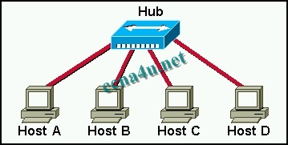](http://answers.ccna4u.net/wp-content/uploads/2011/02/0908.jpg)

**In the graphic, Host A has reached 50% completion in sending a 1 KB Ethernet frame to Host D when Host B wishes to transmit its own frame to Host C. What must Host B do?**  
Host B can transmit immediately since it is connected on its own cable segment.  
Host B must wait to receive a CSMA transmission from the hub, to signal its turn.  
Host B must send a request signal to Host A by transmitting an interframe gap.  
Host B must wait until it is certain that Host A has completed sending its frame.

**2**. **Ethernet operates at which layers of the OSI model? (Choose two.)**  
Network layer  
Transport layer  
Physical layer  
Application layer  
Session layer  
Data-link layer

**3**. **Which of the following describe interframe spacing? (Choose two.)**  
the minimum interval, measured in bit-times, that any station must wait before sending another frame  
the maximum interval, measured in bit-times, that any station must wait before sending another frame  
the 96-bit payload padding inserted into a frame to achieve a legal frame size  
the 96-bit frame padding transmitted between frames to achieve proper synchronization  
the time allowed for slow stations to process a frame and prepare for the next frame  
the maximum interval within which a station must send another frame to avoid being considered unreachable

**4**. **What three primary functions does data link layer encapsulation provide? (Choose three.)**  
addressing  
error detection  
frame delimiting  
port identification  
path determination  
IP address resolution

**5**. **When a collision occurs in a network using CSMA/CD, how do hosts with data to transmit respond after the backoff period has expired?**  
* The hosts return to a listen-before-transmit mode.  
The hosts creating the collision have priority to send data.  
The hosts creating the collision retransmit the last 16 frames.  
The hosts extend their delay period to allow for rapid transmission.

**6**. **What are three functions of the upper data link sublayer in the OSI model? (Choose three.)**  
recognizes streams of bits  
identifies the network layer protocol  
makes the connection with the upper layers  
identifies the source and destination applications  
insulates network layer protocols from changes in physical equipment  
determines the source of a transmission when multiple devices are transmitting

**7**. **What does the IEEE 802.2 standard represent in Ethernet technologies?**  
MAC sublayer  
Physical layer  
Logical Link  
Control sublayer  
Network layer

**8**. **Why do hosts on an Ethernet segment that experience a collision use a random delay before attempting to transmit a frame?**  
A random delay is used to ensure a collision-free link.  
A random delay value for each device is assigned by the manufacturer.  
A standard delay value could not be agreed upon among networking device vendors.  
* A random delay helps prevent the stations from experiencing another collision during the transmission.

**9**.

[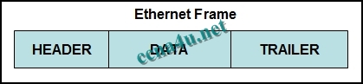](http://answers.ccna4u.net/wp-content/uploads/2011/02/0819.jpg)

**Refer to the exhibit. Which option correctly identifies content that the frame data field may contain?**  
preamble and stop frame  
network layer packet  
physical addressing  
FCS and SoF

**10**. **Host A has an IP address of 172.16.225.93 and a mask of 255.255.248.0. Host A needs to communicate with a new host whose IP is 172.16.231.78. Host A performs the ANDing operation on the destination address. What two things will occur? (Choose two.)**  
Host A will change the destination IP to the IP of the nearest router and forward the packet.  
Host A will broadcast an ARP request for the MAC of its default gateway.  
A result of 172.16.225.0 will be obtained.  
Host A will broadcast an ARP request for the MAC of the destination host.  
A result of 172.16.224.0 will be obtained.  
A result of 172.16.225.255 will be obtained.

**11**. **Which of the following is a drawback of the CSMA/CD access method?**  
Collisions can decrease network performance.  
It is more complex than non-deterministic protocols.  
Deterministic media access protocols slow network performance.  
CSMA/CD LAN technologies are only available at slower speeds than other LAN technologies.

**12**. **Ethernet operates at which layer of the TCP/IP network model?**  
application  
physical  
transport  
internet  
data link  
network access

**13**. **What is the primary purpose of ARP?**  
translate URLs to IP addresses  
resolve IPv4 addresses to MAC addresses  
provide dynamic IP configuration to network devices  
convert internal private addresses to external public addresses

**14**.

[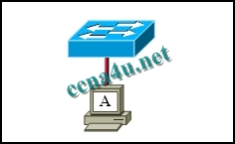](http://answers.ccna4u.net/wp-content/uploads/2011/02/0907.jpg)

**Refer to the exhibit. The switch and workstation are administratively configured for full-duplex operation. Which statement accurately reflects the operation of this link?**  
No collisions will occur on this link.  
Only one of the devices can transmit at a time.  
The switch will have priority for transmitting data.  
The devices will default back to half duplex if excessive collisions occur.

**15**.

[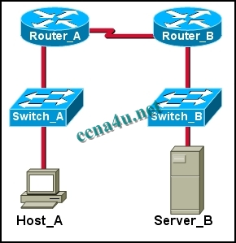](http://answers.ccna4u.net/wp-content/uploads/2011/02/15008.jpg)

**Refer to the exhibit. Host_A is attempting to contact Server_B. Which statements correctly describe the addressing Host_A will generate in the process? (Choose two.)**  
A packet with the destination IP of Router_B.  
A frame with the destination MAC address of Switch_A.  
A packet with the destination IP of Router_A.  
A frame with the destination MAC address of Router_A.  
A packet with the destination IP of Server_B.  
A frame with the destination MAC address of Server_B.

**16**. **Which statements correctly describe MAC addresses? (Choose three.)**  
**dynamically assigned**  
copied into RAM during system startup  
layer 3 address  
contains a 3 byte OUI  
6 bytes long  
32 bits long

**17**. **Which two features make switches preferable to hubs in Ethernet-based networks? (Choose two.)**  
reduction in cross-talk  
minimizing of collisions  
support for UTP cabling  
division into broadcast domains  
increase in the throughput of communications

**18**. **What are the two most commonly used media types in Ethernet networks today? (Choose two.)**  
coaxial thicknet  
copper UTP  
coaxial thinnet  
optical fiber  
shielded twisted pair

**19**. **Convert the binary number 10111010 into its hexadecimal equivalent. Select the correct answer from the list below.**  
85  
90  
BA  
A1  
B3  
1C

**20**. **After an Ethernet collision, when the backoff algorithm is invoked, which device has priority to transmit data?**  
the device involved in the collision with the lowest MAC address  
the device involved in the collision with the lowest IP address  
any device in the collision domain whose backoff timer expires first  
those that began transmitting at the same time

**21**.

**Refer to the exhibit. What command was executed on a host computer to produce the results shown?**  
route PRINT  
arp –a  
arp –d  
netstat  
telnet